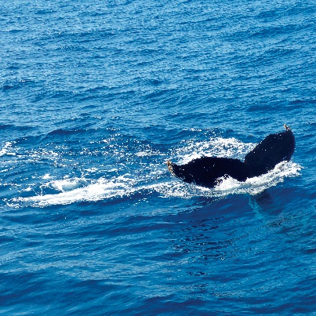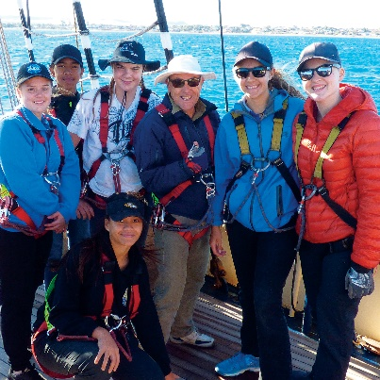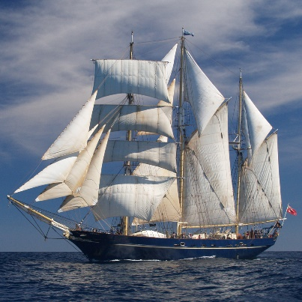
D for Distinction!
Dockside Desk
- Book a lesson on board for:
- Science, Technology, Engineering, Arts, Maths etc
- $250 for 2 hours
- 40 students + teachers. Min age 10 years
Dockside Camp
Book a lesson on board overnight
- $135 each per night includes dinner and breakfast
- 40 people (min 30). Min age 12 years
Day Sails
- $4000 for 4 Hours
- Max 80 Students plus teachers. Min age 10 years
- (~$50/head-teachers free of charge)

Dockside Availability 2019*
Term 4- Oct 14, 15, 16, 17, 18, 21, 22, 23, 24
Nov 25, 26, 27
Dec 2, 3, 4, 13
*Subject to availability at time of booking

Please call Michelle, Education Manager

