2.
Our Fund Yourself Round 2
Welcome Back
How are your savings going? Remember, any savings is a victory. We would like to see you onboard this year so you have a maximum of 9 months to save. Uni students you can save up too, don’t fret.
To jump onboard the 1709 Voyage (30 September – 6 October) you’ll need to save approximately $375 a month. This is doable, so what are we waiting for.
Ideas for saving up
Are you part of a rugby, AFL, netball club…? Why not go to your coach and ask them if you can set up a barbeque with the club and even split the rewards two ways. This way you’re helping your community and they’re helping you too.
Join in your local markets. You can set up a stall and sell clothes you don’t use, hand-craft some pots, or create mini herb pots.
It would be great to hear from you and where you are along your journey. We might even be able to put you in touch with someone close by to organise a barbeque together.
Local Support
Most cities have funding to support your development and encourage new experiences. Have a look online for funding from your local city. We’ve found a few for you.
City of Melville scholarships click here (http://www.melvillecity.com.au/community-and-facilities/community-sport-and-recreation/sports-grants-and-scholarships)
City of Vincent scholarships click here (http://www.vincent.wa.gov.au/Services/Grants_Sponsorship/Youth_Development_Grants)
Are you skilled at making videos? Why not enter this Fremantle Story competition for the chance to win $3 000? https://fremantlestory.com.au/myfreostory-2017.html
Look up your local Rotary or Lions Club as they would really like to help. Click here for rotary clubs in WA. *We’ve made it even easier and written up the postcard for you to send. Email philippa@sailleeuwin.com to get yours.
Max’s Tips
Our handy hints this week are from our volunteer Max in Geraldton. He saved up for his voyage in 2015 and got so much out of contributing to his fare.
Max got a job at Red Rooster and asked his parents and grandparents to match every dollar he earned. This way everyone he contributed to the voyage fare but was able to speed up the process.
Max worked one day a week saving $50 each shift. By the end of 5 months he’d saved up enough for his adventure onboard.
By earning the money himself Max says, “It made me want to enjoy it more and try harder, because of that it felt more rewarding.”
He’s back volunteering this June onboard the Monkey Mia to Geraldton voyage and can’t wait to return.
“It was amazing by the end of the trip the whole group felt like family you make some really good friends. I was one of the youngest on my trip but it didn’t matter I still had the same responsibilities as everyone else. Plus I don’t get sea sick so that was good,” he says.
*Max Tip
Try to limit the amount you spend a week. I also had a jar that I put fake 50 dollar notes in to help visualise the amount. There’s something refreshing about seeing the money that you have earned instead of only in your account.

Are you in Geraldton? The ship has a voyage sailing from Geraldton to Fremantle from 17-23 June. Spots are still available.
Do you want to be included in next month’s newsletter, let me know how you’re tracking.
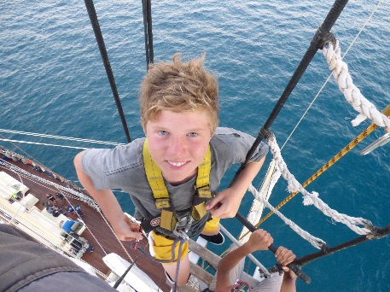
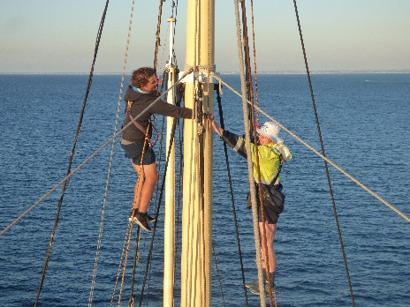
Flick through these photos to see what you’ll be doing onboard. You could be fist-pumping your friend on the 33metre mast too. (All from 1704)
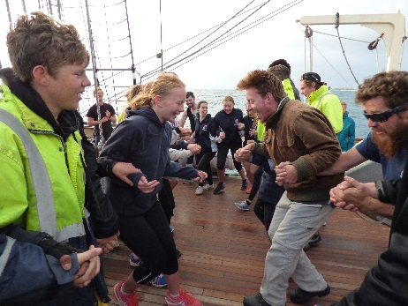

Don’t be ‘argghh-fraid’ come down to the office to get your Fund Yourself Postcards.
A Sailor’s Tale: What keeps a dock floating above water? Pier pressure.

- Hello to our fellow fundraisers!
Firstly, we think you’re awesome for choosing to take part in a Leeuwin Adventure. Now let’s get you onboard.
Set you sights on a voyage and how much you’ll need to save by then. Now you’ve got your head around that we can get started.
Intro
This is the first ever edition of the Fund Yourself news. Here at the Leeuwin we are going to chat to you with ideas of fundraising, celebrate your milestones and put you in contact with others that are fundraising too. It’s a great platform to work together for the same outcome. We will be the engine room, chugging along with others ideas to get onboard. So, make sure you get in contact with us, tell us about your journey and send us your fundraising photos if you want to be in our monthly issue. We’d love to see who you’re meeting with, how you’re fundraising even if it’s cleaning the house, we want to see you in action.
Lexi’s story
Raising your fare is an extremely rewarding experience. It can lead to creating new connections and means your journey with the Leeuwin isn’t only stepping on the ship. Our current volunteer Lexi knows all about the extra-special time onboard, after the hard work she put in fundraising leading up to her voyage.
Lexi got a part time job at McDonalds working on weekends. She put away 40% of her fortnightly pay knowing it was going towards an unforgettable experience. Over six months Lexi had saved up for her voyage deposit. She got a little extra help from her parents too. She knew which voyage she wanted to go on and calculated her savings accordingly. Fundraising with parents, friends, local companies and a part-time job are all different places you can draw from for a Leeuwin voyage.
*Lexi’s hint: Put your money in your parents account or a savings account with no card access so you can’t be tempted to spend the Leeuwin Savings.
Lexi’s says to those starting their journey: “I would certainly save up and do the voyage again, it’s a trip of a lifetime! Because I saved the money and didn't get sponsored or receive a scholarship, I felt as if I got more out of the voyage because I earnt some of the money that went towards my voyage.”
Come say hello
If you’re part of our Fund Yourself group, come into the office and say hello. If the ship’s here we can get you onboard for a photo opportunity that you can use to show off to others your upcoming trip. We want to hear about the ways your fundraising so we can spread the word to others saving up. Email in your handy hints to philippa@sailleeuwin.com.
Pick up your postcards
We’ve made Leeuwin Fundraiser Postcards for you to send to local community groups, friends and family asking for their help with your fundraising. Come into the office and pick up your cards to kick start your journey.

